Brittany Price

CSC 370-001

Morago

25 April 2019

Bayer Filter Reflection

The Bayer Filter is a mosaic that consists of red, blue, and green filters. Most pixels are green followed by blue and red. Every other pixel on each row is green while blue and red are present on alternating rows between the green pixels. The Bayer Filter is used in many color digital cameras and digital images. Here is an example of the Bayer Filter mosaic:

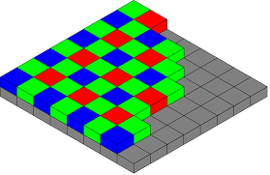

One of the mistakes I made originally was doing three separate iterations of the Bayer Filter for each image. I should have done the Bayer Filter once and just comment out each image during testing. Also, I did not have a way to make sure that the reds and blues were not overlapping with the green pixels. I had the following while iterating over the red and blue pixels:

for(int j = i%2; j < orig.height();j+=2)

instead of :

for(int j = (i+1)%2; j < orig.height();j+=2)

For the reconstruction, I did the same thing and did not get the right result. I also did not average the different channels during the reconstruction process. The mistake I showed above caused my reconstructed images to be completely black.

Here are my updated images:

**Image 1**

Original Image Bayer Filter Reconstructed

 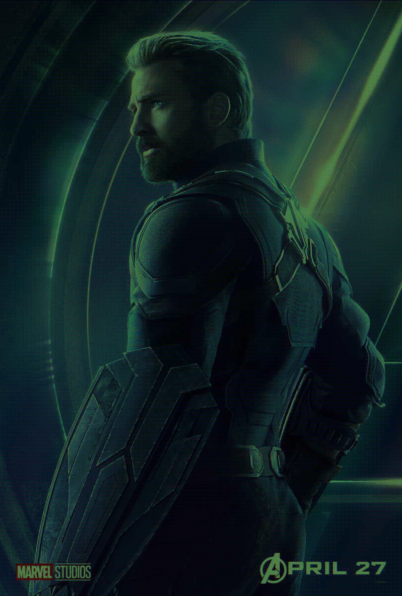 

**Image 2**

Original Bayer Filter

 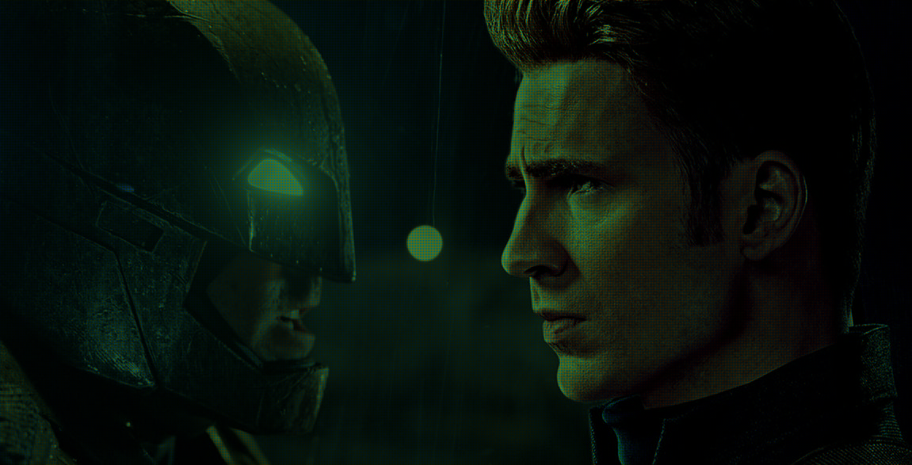

Reconstructed



**Image 3**

Original Bayer Filter Reconstructed

 